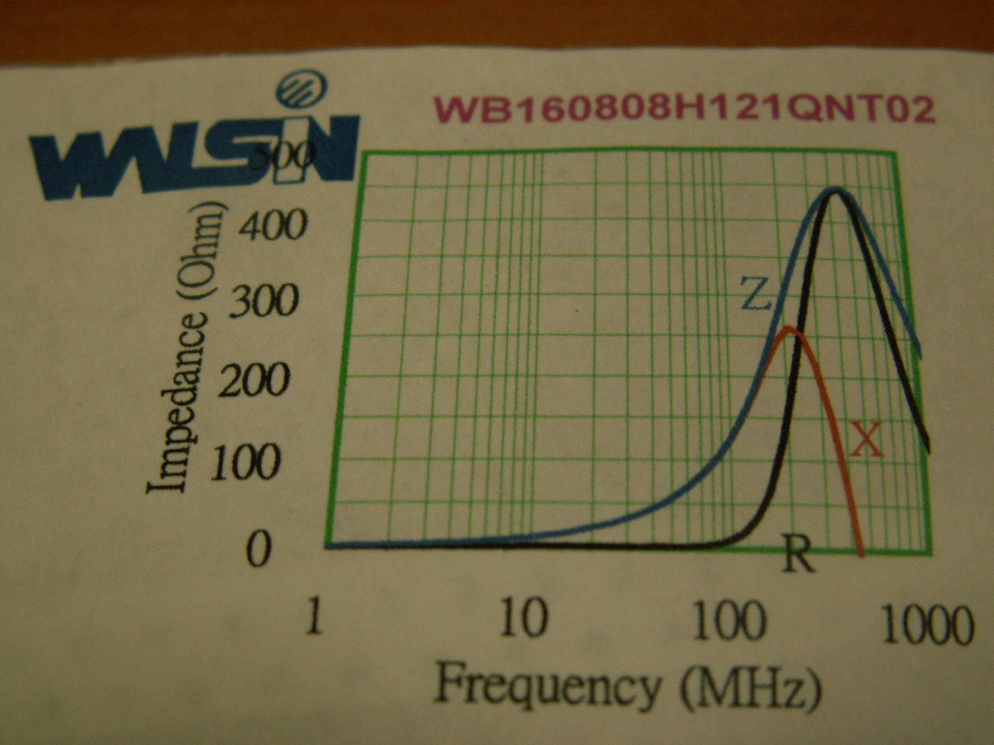
Bead specification

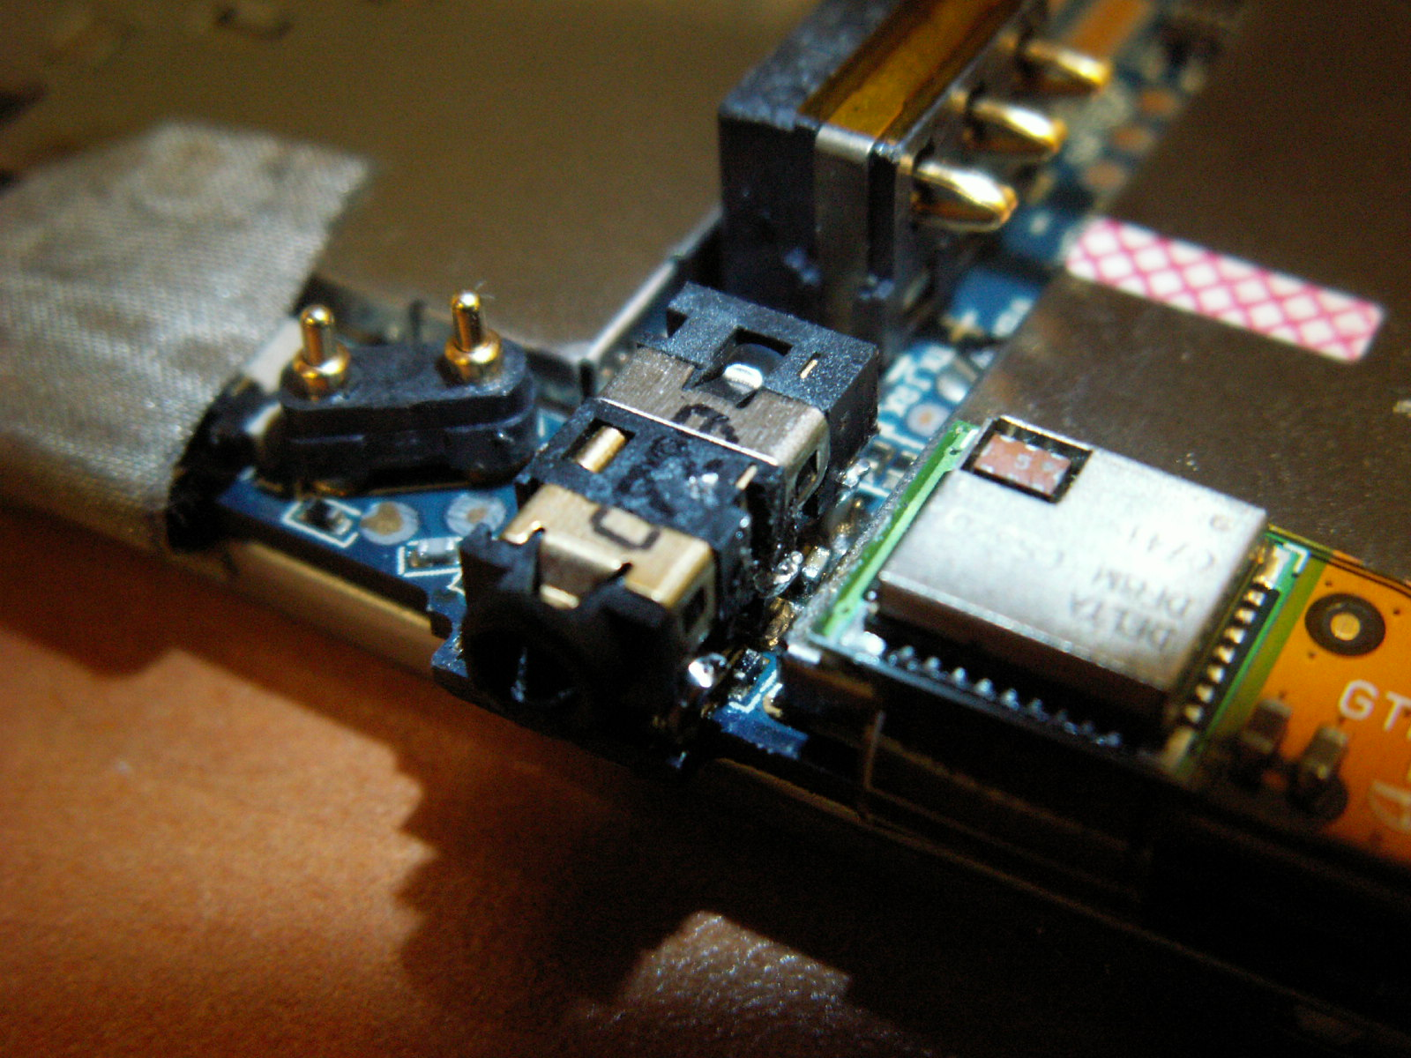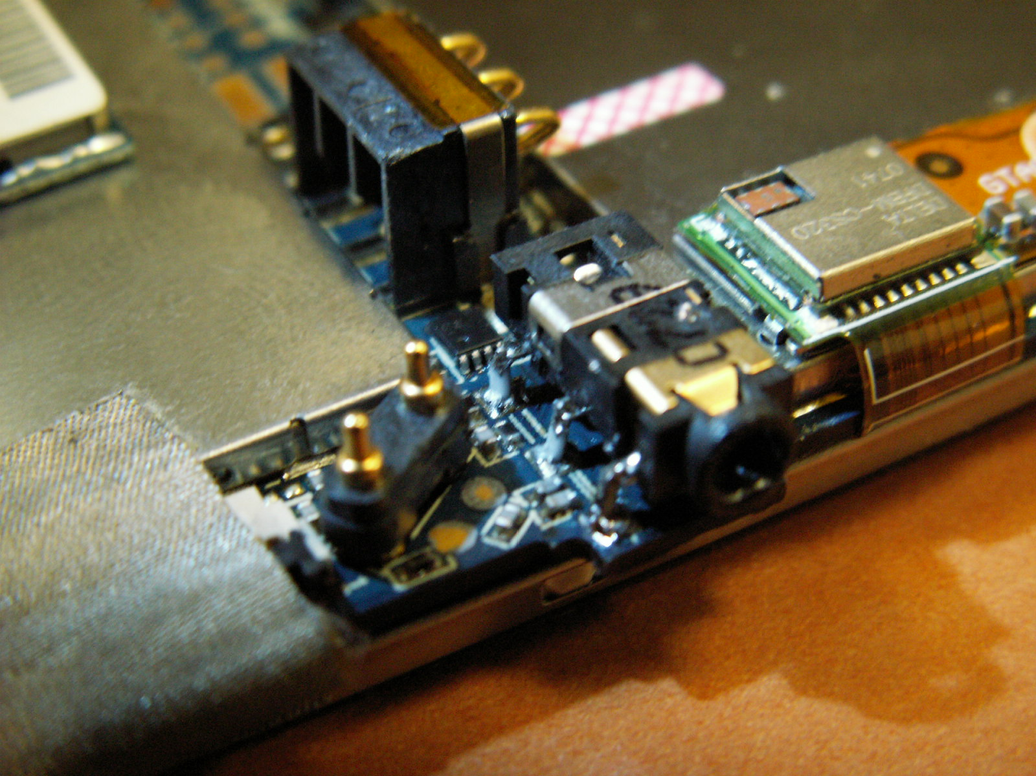
pin1
pin3
pin5
pin6
pin4
pin2
Added bead under the pin4 of earphone jack connector and we will always add 0 ohm resistance in each pin for keeping same height.

